Assessment Team Report

The Assessment Team comprised of the following three members visited the Department of Entomology on May 09, 2012 in order to assess its B.Sc (Hons) Degree Program:

- Prof. Dr. Mian Inayatullah Convener AT
(Dean, Faculty of Crop Protection Sciences)

- Prof. Dr. Farman Ullah External AT Member
(Professor Plant Protection department)

- Prof. Dr. Sajjad Ahmad AT Member
(Professor Entomology)

The above team in its meeting with the Chairman and Dean identified the following Strength and Weaknesses of Program:

Strengths:

- The department has highly qualified staff including six Ph.Ds in the field of Insect Taxonomy, IPM, Ecology/Physiology and Acarology.

- The department has fully equipped labs including high power microscopes, growth chambers and other equipments needed for academic research purposes.

- The department has enough land facility for students’ experiments.

- The faculty members of the departments have completed 10 research projects funded by National and International Donors.

- The faculty members of the department has written 04 books and a lab manual.

- The faculty members and students of the department have access to the diverse insect collection for academic and research purpose.
- Faculty members of entomology department have published more than 300 research articles in National and International Journals.

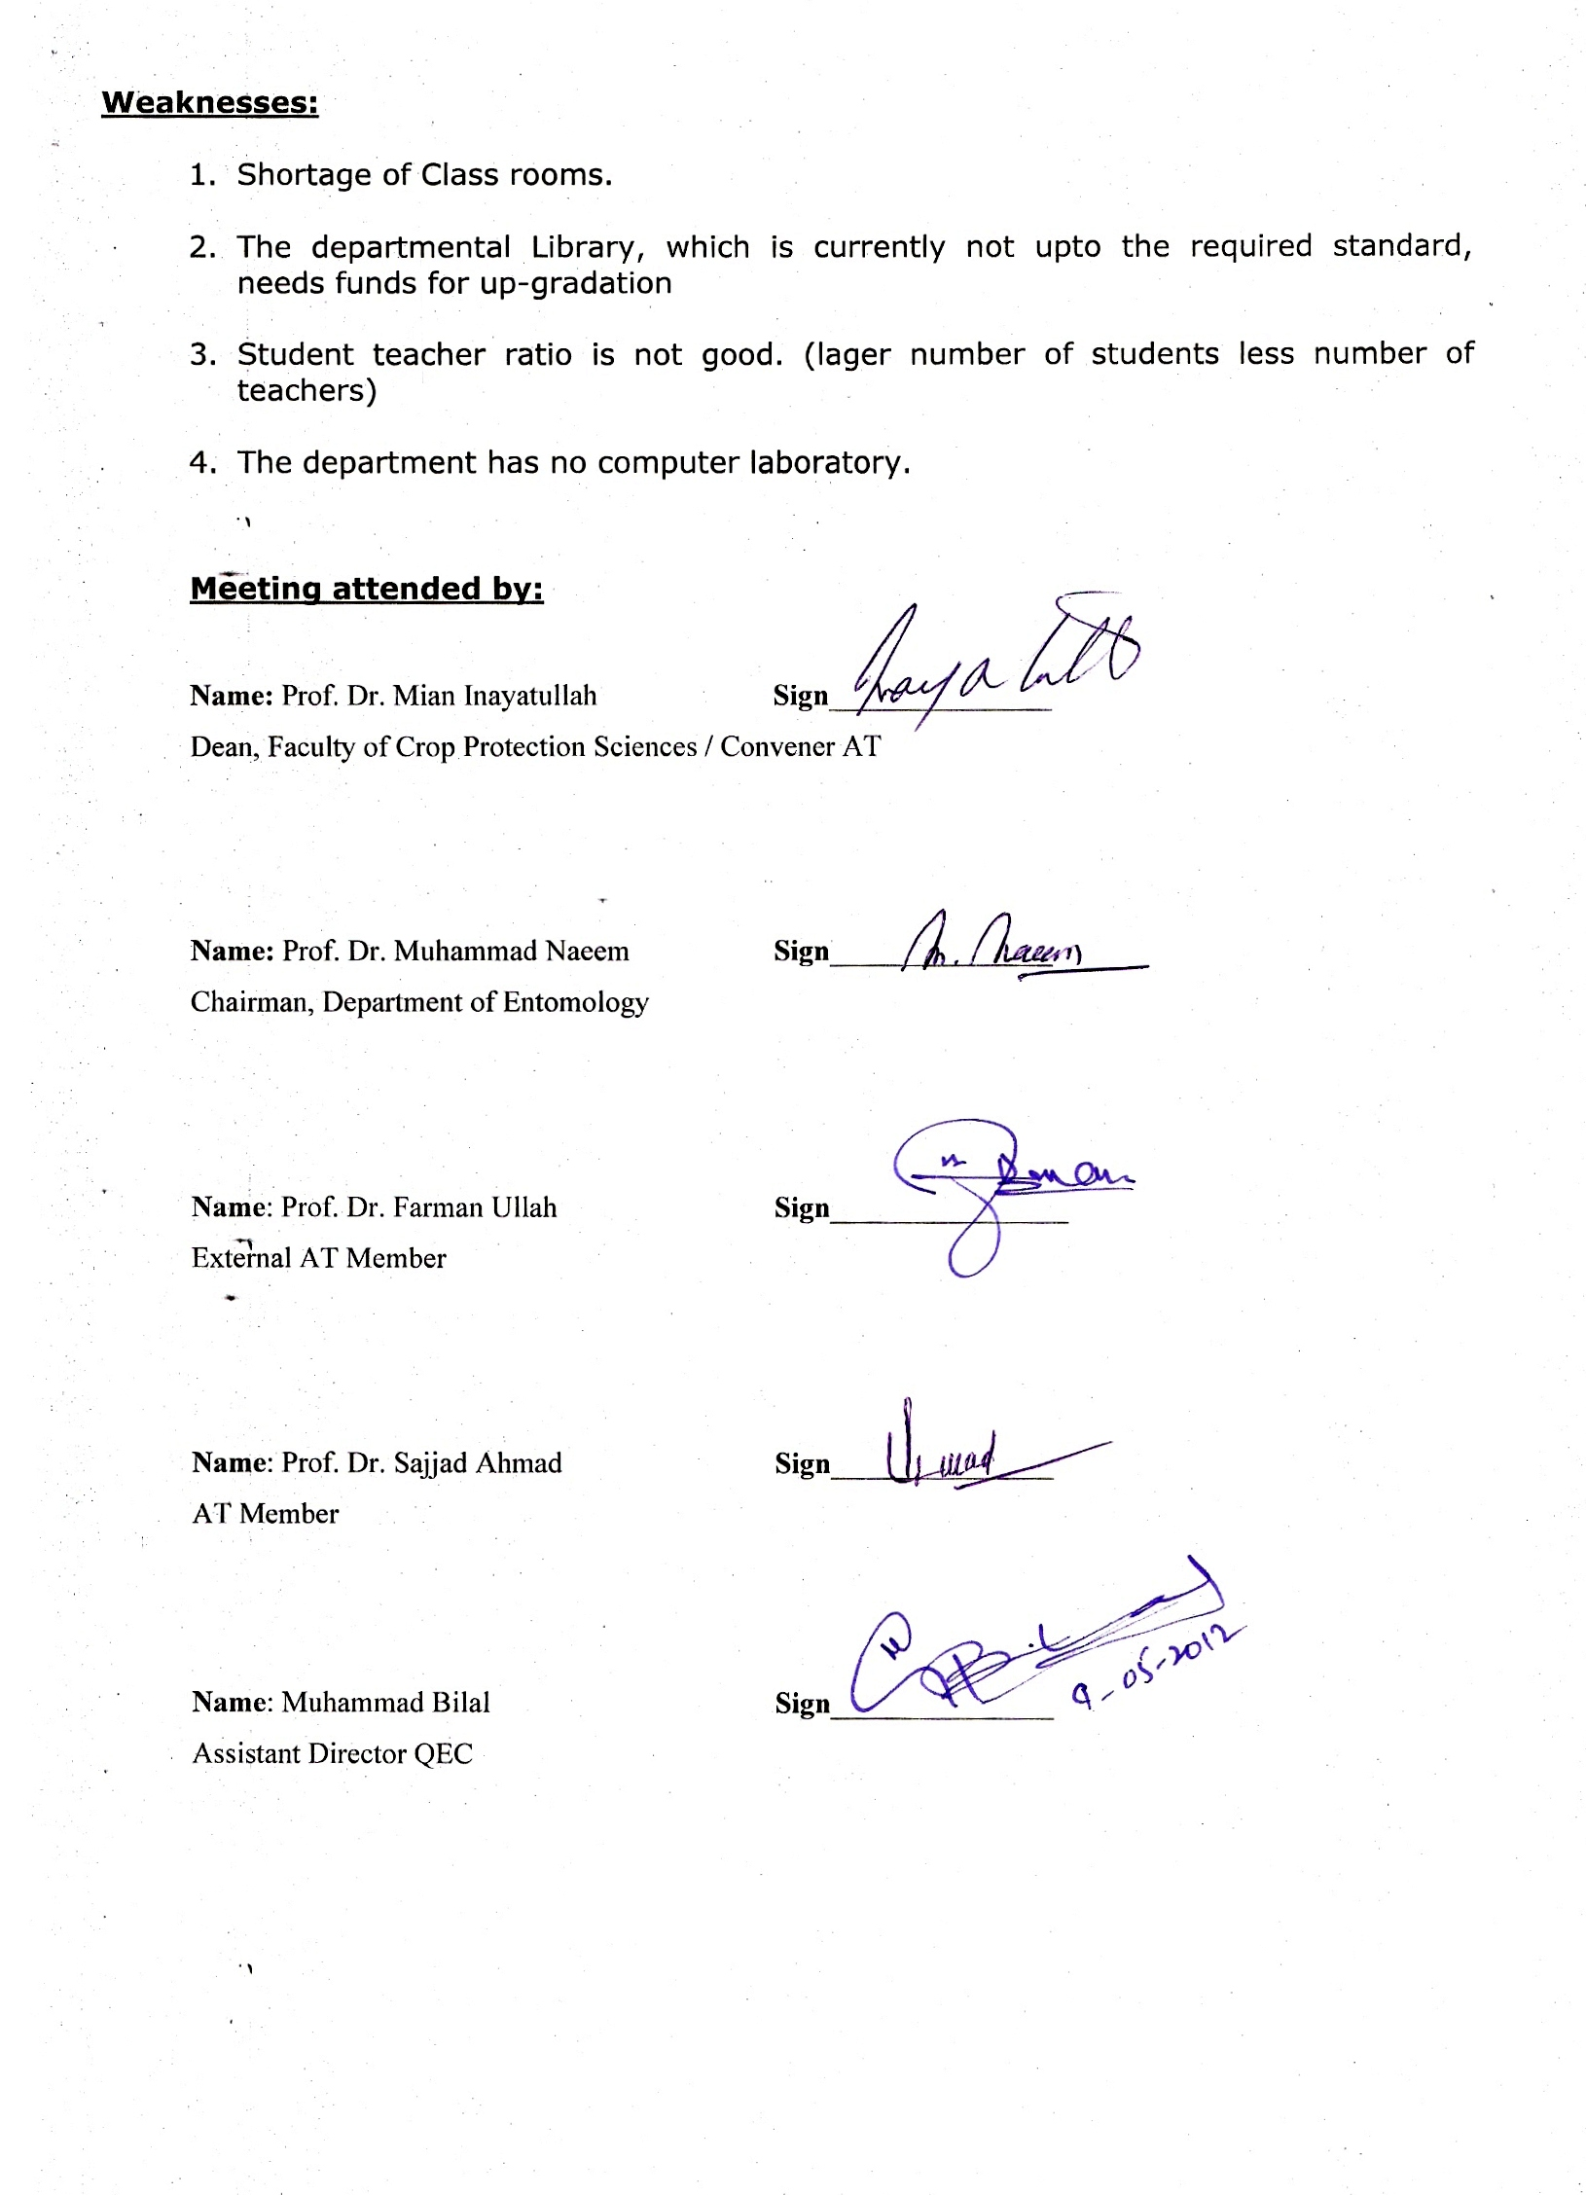
Weaknesses:

- Shortage of Class rooms.

- The departmental Library, which is currently not upto the required standard, needs funds for up-gradation

- Student teacher ratio is not good. (lager number of students less number of teachers)

- The department has no computer laboratory.

Meeting attended by:

Name: Prof. Dr. Mian Inayatullah Sign_______________
Dean, Faculty of Crop Protection Sciences / Convener AT

Name: Prof. Dr. Muhammad Naeem Sign_______________
Chairman, Department of Entomology

Name: Prof. Dr. Farman Ullah Sign________________
External AT Member

Name: Prof. Dr. Sajjad Ahmad Sign_______________
AT Member

Name: Muhammad Bilal Sign_______________
Assistant Director QEC

